**CS355 Mini Project Assignment – AUTUMN 2020**

**PACKAGE DELIVERY COMPANY DATABASE**

**Name - Chandrawanshi Mangesh Shivaji**

**Roll No. - 1801CS16**

**Date – 30/11/2020**

**ER DIAGRAM:**

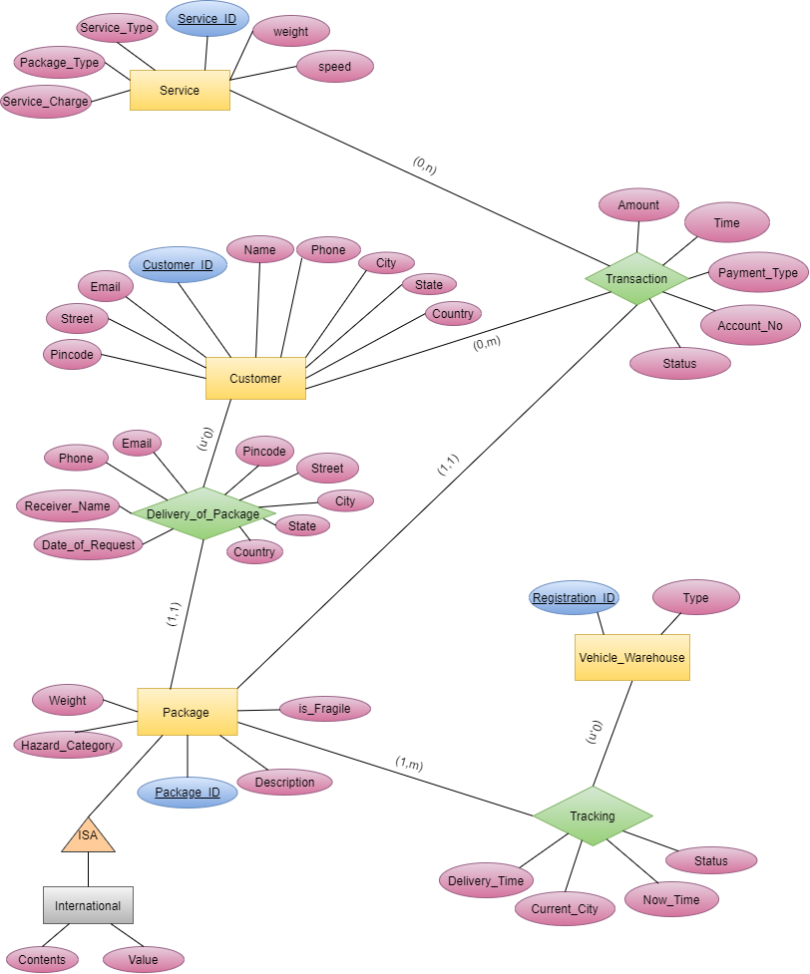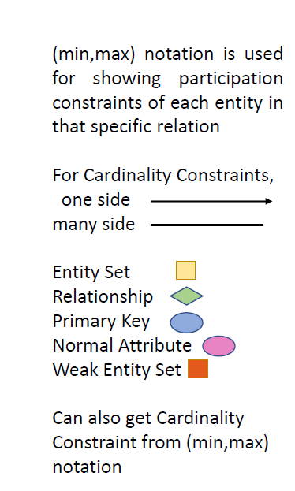

**RELATIONAL MODEL PICTORIAL REP.:**

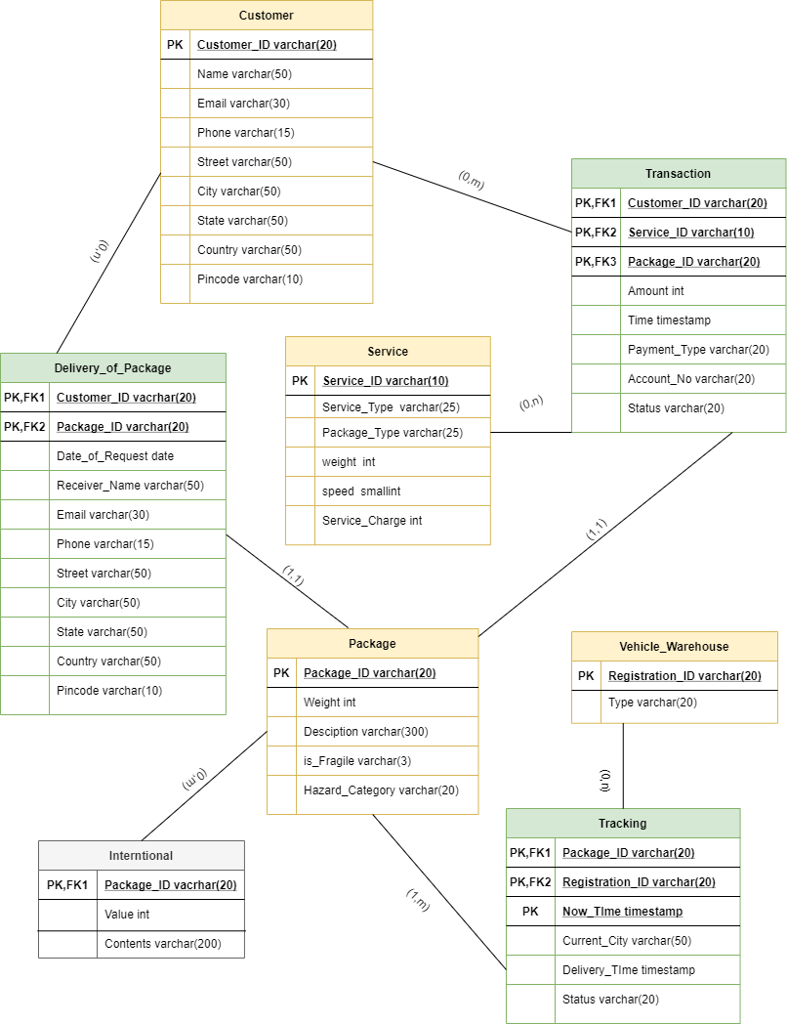

**CREATE ALL TABLES:**

// is used to add description comments

// Sign in as root

mysql -u root -p

- Password

// Create Database for Package Delivery Company

create database Package_Delivery_Company;

use Package_Delivery_Company;

// Create all the required tables

create table Package(

Package_ID varchar(20),

Weight int unsigned,

Description varchar(300),

is_Fragile varchar(3) NOT NULL,

Hazard_Category varchar(20),

constraint Package_pk primary key (Package_ID)

);

create table International(

Package_ID varchar(20),

Value int unsigned,

Contents varchar(200),

constraint International_pk primary key (Package_ID),

constraint International_fk1 foreign key (Package_ID) references Package(Package_ID)

);

create table Customer(

Customer_ID varchar(20),

Name varchar(50),

Email varchar(30),

Phone varchar(15),

Street varchar(50),

City varchar(50),

State varchar(50),

Country varchar(50),

Pincode varchar(10),

constraint Customer_pk primary key (Customer_ID)

);

create table Delivery_of_Package(

Customer_ID varchar(20),

Package_ID varchar(20),

Date_of_Request date,

Receiver_Name varchar(50),

Email varchar(30),

Phone varchar(15),

Street varchar(50),

City varchar(50),

State varchar(50),

Country varchar(50),

Pincode varchar(10),

constraint Delivery_of_Package_pk primary key (Customer_ID,Package_ID),

constraint Delivery_of_Package_fk1 foreign key (Customer_ID) references Customer(Customer_ID),

constraint Delivery_of_Package_fk2 foreign key (Package_ID) references Package(Package_ID)

);

create table Service(

Service_ID varchar(10),

Service_Type varchar(25),

Package_Type varchar(25),

Weight int unsigned,

Speed smallint unsigned,

Service_Charge int,

constraint Service_pk primary key (Service_ID)

);

create table Transactions(

Customer_ID varchar(20),

Service_ID varchar(10),

Package_ID varchar(20),

Amount int unsigned,

Time timestamp,

Payment_Type varchar(20),

Account_No varchar(20),

Status varchar(20),

constraint Transactions_pk primary key (Customer_ID,Service_ID,Package_ID),

constraint Transactions_fk1 foreign key (Customer_ID) references Customer(Customer_ID),

constraint Transactions_fk2 foreign key (Package_ID) references Package(Package_ID),

constraint Transactions_fk3 foreign key (Service_ID) references Service(Service_ID)

);

create table Vehicle_Warehouse(

Registration_ID varchar(20),

Type varchar(20),

constraint Vehicle_Warehouse_pk primary key (Registration_ID)

);

create table Tracking(

Package_ID varchar(20),

Registration_ID varchar(20),

Now_Time timestamp,

Current_City varchar(50),

Delivery_Time timestamp,

Status varchar(20),

constraint Tracking_pk primary key (Package_ID,Registration_ID,Now_Time),

constraint Tracking_fk1 foreign key (Registration_ID) references Vehicle_Warehouse(Registration_ID),

constraint Tracking_fk2 foreign key (Package_ID) references Package(Package_ID)

);

**FILL ALL TABLES USING PROCEDURES:**

delimiter $$

// **Procedure to fill Package table**

create procedure procPkgDummyData(in n int)

begin

declare Package_ID1 varchar(20);

declare Weight1 int unsigned;

declare Description1 varchar(300);

declare is_Fragile1 varchar(3);

declare Hazard_Category1 varchar(20);

declare iter int;

declare chk int;

declare random_num int;

set iter = 0;

while(iter < n) do

set Package_ID1 = concat('pkg_',lpad(conv(floor(rand()*pow(36,8)), 10, 36), 8, 0),lpad(conv(floor(rand()*pow(36,8)), 10, 36), 8, 0));

set Weight1 = floor(rand()*999999) + 1;

set Description1 = concat('desc_',substring('ABCDEFGHIJKLMNOPQRSTUVWXYZ',floor(10*rand() + 1),10));

set random_num = floor(rand()*4 + 1);

if (random_num = 4) then

set is_Fragile1 = 'YES';

else

set is_Fragile1 = 'NO';

end if;

set random_num = floor(rand()*1000 + 1);

if (random_num = 250) then

set Hazard_Category1 = 'EXPLOSIVE';

elseif (random_num = 500) then

set Hazard_Category1 = 'FlAMMABLE';

elseif (random_num = 750) then

set Hazard_Category1 = 'POISONOUS';

elseif (random_num = 1000) then

set Hazard_Category1 = 'RADIOACTIVE';

else

set Hazard_Category1 = 'NONE';

end if;

select exists (

select Package_ID

from Package

where Package_ID = Package_ID1

) into chk;

if (chk = 0) then

insert into package

values(Package_ID1,Weight1,Description1,is_Fragile1,Hazard_Category1);

set iter = iter + 1;

end if;

end while;

end $$

delimiter ;

call procPkgDummyData(1000);

// **Procedure to fill international table**

delimiter $$

create procedure procIntrDummyData(in n int)

begin

declare Package_ID1 varchar(20);

declare Value1 int unsigned;

declare Contents1 varchar(200);

declare iter int;

declare chk int;

declare random_num int;

set iter = 0;

while(iter < n) do

select Package_ID

into Package_ID1

from Package

Order by rand()

limit 1;

set Value1 = floor(rand()*9999) + 1;

set Contents1 = concat('desc_',substring('ABCDEFGHIJKLMNOPQRSTUVWXYZ',floor(10*rand() + 1),10));

select exists (

select Package_ID

from International

where Package_ID = Package_ID1

) into chk;

if (chk = 0) then

insert into International

values(Package_ID1,Value1,Contents1);

set iter = iter + 1;

end if;

end while;

end $$

delimiter ;

call procIntrDummyData(50);

// **Procedure to fill Customer table**

delimiter $$

create procedure procCustDummyData(in n int)

begin

declare Customer_ID1 varchar(20);

declare Name1 varchar(50);

declare Email1 varchar(30);

declare Phone1 varchar(15);

declare Street1 varchar(50);

declare City1 varchar(50);

declare State1 varchar(50);

declare Country1 varchar(50);

declare Pincode1 varchar(10);

declare iter int;

declare chk int;

declare random_num int;

set iter = 0;

while(iter < n) do

set Customer_ID1 = concat('cus_',lpad(conv(floor(rand()*pow(36,8)), 10, 36), 8, 0),lpad(conv(floor(rand()*pow(36,8)), 10, 36), 8, 0));

select exists (

select Customer_ID

from Customer

where Customer_ID = Customer_ID1

) into chk;

set Name1 = substring('ABCDEFabcRSTUVdefghijklMNOPQWXYZmnopqrsGHIJKLtuvwxyz',floor(rand()*25)+1,floor(rand()*25+1));

set Email1 = concat(substring('ABCDEFabcRSTUVdefghijklMNOPQWXYZmnopqrsGHIJKLtuvwxyz',floor(rand()*25)+1,floor(rand()*10)+1),'@domain.com');

set Phone1 = lpad(floor(rand()*10000000000),10,'0');

set Street1 = substring('ABCDEFabcRSTUVdefghijklMNOPQWXYZmnopqrsGHIJKLtuvwxyz',floor(rand()*25)+1,floor(rand()*20+1));

set City1 = substring('ABCDEFabcRSTUVdefghijklMNOPQWXYZmnopqrsGHIJKLtuvwxyz',floor(rand()*25)+1,floor(rand()*6)+1);

set State1 = substring('ABCDEFabcRSTUVdefghijklMNOPQWXYZmnopqrsGHIJKLtuvwxyz',floor(rand()*25)+1,floor(rand()*7)+1);

set Country1 = substring('ABCDEFabcRSTUVdefghijklMNOPQWXYZmnopqrsGHIJKLtuvwxyz',floor(rand()*25)+1,floor(rand()*9)+1);

set Pincode1 = lpad(floor(rand()*10000000000),8,'0');

if (chk = 0) then

insert into Customer

values(Customer_ID1,Name1,Email1,Phone1,Street1,City1,State1,Country1,Pincode1);

set iter = iter + 1;

end if;

end while;

end $$

delimiter ;

call procCustDummyData(1000);

// **Procedure to fill Delivery_of_Package table**

delimiter $$

create procedure procDoPDummyData(in n int)

begin

declare Customer_ID1 varchar(20);

declare Package_ID1 varchar(20);

declare Date_of_Request date;

declare Receiver_Name1 varchar(50);

declare Email1 varchar(30);

declare Phone1 varchar(15);

declare Street1 varchar(50);

declare City1 varchar(50);

declare State1 varchar(50);

declare Country1 varchar(50);

declare Pincode1 varchar(10);

declare iter int;

declare chk int;

declare random_num int;

set iter = 0;

while(iter < n) do

select Package_ID

into Package_ID1

from Package

Order by rand()

limit 1;

select Customer_ID

into Customer_ID1

from Customer

Order by rand()

limit 1;

select exists (

select Customer_ID,Package_ID

from Delivery_of_Package

where Package_ID = Package_ID1 and Customer_ID = Customer_ID1

) into chk;

SELECT FROM_UNIXTIME(UNIX_TIMESTAMP('2018-01-01 00:00:000') + FLOOR(0 + (RAND() * 63072000))) INTO Date_of_Request;

set Receiver_Name1 = substring('ABCDEFabcRSTUVdefghijklMNOPQWXYZmnopqrsGHIJKLtuvwxyz',floor(rand()*25)+1,floor(rand()*25)+1);

set Email1 = concat(substring('ABCDEFabcRSTUVdefghijklMNOPQWXYZmnopqrsGHIJKLtuvwxyz',floor(rand()*25)+1,floor(rand()*10)+1),'@domain.com');

set Phone1 = lpad(floor(rand()*10000000000),10,'0');

set Street1 = substring('ABCDEFabcRSTUVdefghijklMNOPQWXYZmnopqrsGHIJKLtuvwxyz',floor(rand()*25)+1,floor(rand()*20)+1);

set City1 = substring('ABCDEFabcRSTUVdefghijklMNOPQWXYZmnopqrsGHIJKLtuvwxyz',floor(rand()*25)+1,floor(rand()*6)+1);

set State1 = substring('ABCDEFabcRSTUVdefghijklMNOPQWXYZmnopqrsGHIJKLtuvwxyz',floor(rand()*25)+1,floor(rand()*7)+1);

set Country1 = substring('ABCDEFabcRSTUVdefghijklMNOPQWXYZmnopqrsGHIJKLtuvwxyz',floor(rand()*25)+1,floor(rand()*9)+1);

set Pincode1 = lpad(floor(rand()*10000000000),8,'0');

if (chk = 0) then

insert into Delivery_of_Package

values(Customer_ID1,Package_ID1,Date_of_Request,Receiver_Name1,Email1,Phone1,Street1,City1,State1,Country1,Pincode1);

set iter = iter + 1;

end if;

end while;

end $$

delimiter ;

call procDoPDummyData(1000);

// **Procedure to fill Service Table**

delimiter $$

create procedure procServDummyData(in n int)

begin

declare Service_ID1 varchar(10);

declare Service_Type1 varchar(25);

declare Package_Type1 varchar(25);

declare Weight1 int;

declare Service_Charge1 int;

declare Speed1 smallint;

declare iter int;

declare chk int;

declare random_num int;

set iter = 0;

while(iter < n) do

set Service_ID1 = concat('s_',lpad(conv(floor(rand()*pow(36,8)), 10, 36), 8, 0));

select exists (

select Service_ID

from Service

where Service_ID = Service_ID1

) into chk;

set random_num = floor(rand()*3);

if(random_num < 1) then

set Service_Type1 = 'Prepaid';

elseif(random_num < 2) then

set Service_Type1 = 'Postpaid';

else

set Service_Type1 = 'Other';

end if;

set random_num = floor(rand()*4);

if(random_num < 1) then

set Package_Type1 = 'Small Box';

elseif(random_num < 2) then

set Package_Type1 = 'Large Box';

elseif(random_num < 3) then

set Package_Type1 = 'Medium Box';

else

set Package_Type1 = 'Flat Envelope';

end if;

set Weight1 = floor(rand()*999999) + 1;

set Service_Charge1 = floor(rand()*10000) + 1;

set Speed1 = floor(rand()*14) + 1;

if (chk = 0) then

insert into Service

values(Service_ID1,Service_Type1,Package_Type1,Weight1,Speed1, Service_Charge1);

set iter = iter + 1;

end if;

end while;

end$$

delimiter ;

call procServDummyData(500);

// **Procedure to fill Transactions Table**

delimiter $$

create procedure procTransDummyData(in n int)

begin

declare Customer_ID1 varchar(20);

declare Service_ID1 varchar(10);

declare Package_ID1 varchar(20);

declare Amount1 int;

declare Time1 timestamp;

declare Payment_Type1 varchar(20);

declare Account_No1 varchar(20);

declare Status1 varchar(20);

declare Service_Charge1 int;

declare Speed1 smallint;

declare random_date date;

declare iter int;

declare chk int;

declare random_num int;

set iter = 0;

while(iter < n) do

select Package_ID

into Package_ID1

from Package

Order by rand()

limit 1;

select Service_ID

into Service_ID1

from Service

Order by rand()

limit 1;

select Customer_ID

into Customer_ID1

from Customer

Order by rand()

limit 1;

select exists (

select Customer_ID,Service_ID,Package_ID

from Transactions

where Package_ID = Package_ID1 and Service_ID1 = Service_ID and Customer_ID = Customer_ID1

) into chk;

select Service_Charge into Amount1

from Service

where Service_ID = Service_ID1;

set random_num = floor(rand()*4);

if(random_num < 1) then

set Payment_Type1 = 'Credit Card';

elseif(random_num < 2) then

set Payment_Type1 = 'Debit Card';

elseif(random_num < 3) then

set Payment_Type1 = 'Internet Banking';

else

set Payment_Type1 = 'UPI';

end if;

select exists(

select Date_of_Request

from Delivery_of_Package

where Customer_ID = Customer_ID1 and Package_ID = Package_ID1

) into chk;

set Account_No1 = floor(rand()*999999999) + 1;

set Status1 = 'Successful';

select from_unixtime(unix_timestamp('2018-01-01 01:00:00')+floor(rand()*31536000)) into Time1;

if (chk = 0) then

insert into Transactions

values(Customer_ID1,Service_ID1,Package_ID1,Amount1,Time1,Payment_Type1,Account_No1,Status1);

set iter = iter + 1;

end if;

end while;

end$$

delimiter ;

call procTransDummyData(1000);

// **Procedure to fill Vehicle_Warehouse Table**

delimiter $$

create procedure procVeWaDummyData(in n int)

begin

declare Registration_ID1 varchar(20);

declare Type1 varchar(20);

declare iter int;

declare chk int;

declare random_num int;

set iter = 0;

while(iter < n) do

set Registration_ID1 = concat('reg_',lpad(conv(floor(rand()*pow(36,8)), 10, 36), 8, 0),lpad(conv(floor(rand()*pow(36,8)), 10, 36), 8, 0));

select exists (

select Registration_ID

from Vehicle_Warehouse

where Registration_ID = Registration_ID1

) into chk;

set random_num = floor(rand()*4);

if(random_num < 1) then

set Type1 = 'Truck';

elseif(random_num < 2) then

set Type1 = 'Plane';

elseif(random_num < 3) then

set Type1 = 'Train';

else

set Type1 = 'Warehouse';

end if;

if (chk = 0) then

insert into Vehicle_Warehouse

values(Registration_ID1,Type1);

set iter = iter + 1;

end if;

end while;

end$$

delimiter ;

call procVeWaDummyData(2000);

// **Procedure to fill Tracking Table**

delimiter $$

create procedure procTracDummyData(in n int)

begin

declare Package_ID1 varchar(20);

declare Registration_ID1 varchar(20);

declare Now_Time1 timestamp;

declare Current_City1 varchar(50);

declare Delivery_Time1 timestamp;

declare Status1 varchar(20);

declare Start_Time timestamp;

declare iter int;

declare iter1 int;

declare chk int;

declare random_num int;

set iter = 0;

while (iter < n) do

select Package_ID

into Package_ID1

from Package

Order by rand()

limit 1;

select Registration_ID

into Registration_ID1

from Vehicle_Warehouse

Order by rand()

limit 1;

set Delivery_Time1 = NULL;

set Status1 = 'Out for Delivery';

select TIMESTAMP(Date_of_Request) into Start_Time from Delivery_of_Package where Package_ID = Package_ID1 limit 1;

set iter1 = 0;

set random_num = floor(rand()*5 + 1);

while (iter1 < random_num) do

set Current_City1 = substring('ABCDEFabcRSTUVdefghijklMNOPQWXYZmnopqrsGHIJKLtuvwxyz',floor(rand()*25)+1,floor(rand()*6)+1);

select Registration_ID

into Registration_ID1

from Vehicle_Warehouse

Order by rand()

limit 1;

select from_unixtime(unix_timestamp(Start_Time) + floor(500 + (rand() * 172800))) into Now_Time1;

set Start_Time = Now_Time1;

set Delivery_Time1 = FROM_UNIXTIME(UNIX_TIMESTAMP(Start_Time) + FLOOR(0 + (RAND() * 172800)));

if (iter1 = random_num-1) then

set Status1 = 'Delivered';

set Delivery_Time1 = Start_Time;

end if;

insert into Tracking

values(Package_ID1,Registration_ID1,Now_Time1,Current_City1,Delivery_Time1,Status1);

set iter1 = iter1 + 1;

end while;

set iter = iter + 1;

end while;

end $$

delimiter ;

call procTracDummyData(1000);

// **Size of All Tables (Can be Modified/Increased using above procedures)**

mysql> select count(*) from customer;

+----------+

| count(*) |

+----------+

| 1000 |

+----------+

1 row in set (0.20 sec)

mysql> select count(*) from delivery_of_package;

+----------+

| count(*) |

+----------+

| 1000 |

+----------+

1 row in set (0.03 sec)

mysql> select count(*) from international;

+----------+

| count(*) |

+----------+

| 50 |

+----------+

1 row in set (0.01 sec)

mysql> select count(*) from package;

+----------+

| count(*) |

+----------+

| 1000 |

+----------+

1 row in set (0.00 sec)

mysql> select count(*) from service;

+----------+

| count(*) |

+----------+

| 500 |

+----------+

1 row in set (0.04 sec)

mysql> select count(*) from tracking;

+----------+

| count(*) |

+----------+

| 2967 |

+----------+

1 row in set (0.00 sec)

mysql> select count(*) from transactions;

+----------+

| count(*) |

+----------+

| 1000 |

+----------+

1 row in set (0.14 sec)

mysql> select count(*) from vehicle_warehouse;

+----------+

| count(*) |

+----------+

| 2000 |

+----------+

1 row in set (0.14 sec)

mysql> select count(*) from vehicle_warehouse;

+----------+

| count(*) |

+----------+

| 2000 |

+----------+

1 row in set (0.00 sec)

// **Export Data in all Tables to csv files**

SELECT * INTO outfile 'C:/ProgramData/MySQL/MySQL Server 8.0/Uploads/Package.csv'

fields terminated by ','

lines terminated by '\n' FROM Package;

SELECT * INTO outfile 'C:/ProgramData/MySQL/MySQL Server 8.0/Uploads/International.csv'

fields terminated by ','

lines terminated by '\n' FROM International;

SELECT * INTO outfile 'C:/ProgramData/MySQL/MySQL Server 8.0/Uploads/Customer.csv'

fields terminated by ','

lines terminated by '\n' FROM Customer;

SELECT * INTO outfile 'C:/ProgramData/MySQL/MySQL Server 8.0/Uploads/Delivery_of_Package.csv'

fields terminated by ','

lines terminated by '\n' FROM Delivery_of_Package;

SELECT * INTO outfile 'C:/ProgramData/MySQL/MySQL Server 8.0/Uploads/Service.csv'

fields terminated by ','

lines terminated by '\n' FROM Service;

SELECT * INTO outfile 'C:/ProgramData/MySQL/MySQL Server 8.0/Uploads/Transactions.csv'

fields terminated by ','

lines terminated by '\n' FROM Transactions;

SELECT * INTO outfile 'C:/ProgramData/MySQL/MySQL Server 8.0/Uploads/Vehicle_Warehouse.csv'

fields terminated by ','

lines terminated by '\n' FROM Vehicle_Warehouse;

SELECT * INTO outfile 'C:/ProgramData/MySQL/MySQL Server 8.0/Uploads/Tracking.csv'

fields terminated by ','

lines terminated by '\n' FROM Tracking;

**// Given Queries**

Assume a delivery truck (say truck no 1721) is destroyed in a crash.

**##Find all customers who had a package on that truck at the time of the crash**.

select Name from Customer where Customer_ID in(

select Customer_ID from Delivery_of_Package where Package_ID in(

select distinct Package_ID from Tracking where Registration_ID = '1721' and status != 'Delivered'));

// For My Data

select Name from Customer where Customer_ID in(

select Customer_ID from Delivery_of_Package where Package_ID in(

select distinct Package_ID from Tracking where Registration_ID = 'reg_75URYFEQ0R7HF109' and status != 'Delivered'));

**##Find all recipients who had a package on that truck at the time of the crash.**

select Receiver_Name from Delivery_of_Package where Package_ID in(

select distinct Package_ID from Tracking where Registration_ID='1721' and status != 'Delivered');

// For My Data

select Receiver_Name from Delivery_of_Package where Package_ID in(

select distinct Package_ID from Tracking where Registration_ID='reg_75URYFEQ0R7HF109' and status != 'Delivered');

**##Find the last successful delivery by that truck prior to the crash.**

select Package_ID from Tracking where Delivery_Time in(

select max(Delivery_Time) from Tracking where Registration_ID='1721' and status='Delivered');

// For My Data

select Package_ID from Tracking where Delivery_Time in(

select max(Delivery_Time) from Tracking where Registration_ID='reg_75URYFEQ0R7HF109' and status='Delivered');

**##Find the customer who has shipped the most packages in the past year.**

select Customer_ID from Delivery_of_Package where year(Date_of_Request)=2019 group by Customer_ID order by count(*) desc limit 1;

**##Find the customer who has spent the most money on shipping in the past year**.

select Customer_ID from Transactions where year(Time)=2019 group by Customer_ID order by sum(Amount) desc limit 1;

**##Find the street with the most customers**.

select Street from Customer group by Street order by count(*) desc limit 1;

##Find those packages that were not delivered within the promised time.

select * from Package where Package_ID in(

select Transactions.Package_ID from Transactions, Tracking, Delivery_of_Package, Service where Transactions.Package_ID = Tracking.Package_ID and Transactions.Service_ID = Service.Service_ID and Delivery_of_Package.Package_ID = Transactions.Package_ID and date_add(Delivery_of_Package.Date_of_Request,interval Speed day) < Tracking.Now_Time);

**##Take Customer ID and provide the details such as customer name, address, and amount owed.**

select distinct Customer.Customer_ID, Customer.Name, Transactions.Amount, Customer.Pincode, Customer.Street, Customer.City, Customer.State, Customer.Country, Customer.Email, Customer.Phone

from Customer, Transactions

where Customer.Customer_ID = Transactions.Customer_ID and Transactions.Service_ID in(

select Service_ID from Service where Service_Type = 'Postpaid')

union

select distinct Customer.Customer_ID, Customer.Name, 0, Customer.Pincode, Customer.Street, Customer.City, Customer.State, Customer.Country, Customer.Email, Customer.Phone

from Customer, Transactions

where Customer.Customer_ID = Transactions.Customer_ID and Transactions.Service_ID in(

select Service_ID from Service where Service_Type != 'Postpaid')

union

select distinct Customer.Customer_ID, Customer.Name, 0, Customer.Pincode, Customer.Street, Customer.City, Customer.State, Customer.Country, Customer.Email, Customer.Phone

from Customer where Customer.Customer_ID not in (select Customer_ID from Transactions);

**##A bill listing charges by type of service.**

Select * from Service;

**##An itemize billing listing each individual shipment and the charges for it.**

Select * from Transactions;

**EXTRA QUERIES**

**## Find Package ID all the non hazardous international shipments**

select International.Package_ID

from International,Package

where International.Package_ID = Package.Package_ID and Hazard_Category = 'None';

**## Find the name of all customers who have shipped international packages.**

select Name from Customer

where Customer_ID IN(

select Customer_ID

from Delivery_of_Package

where Package_ID IN

(SELECT Package_ID

FROM International));

**ADDING INDEX**

As in most of the cases for querying we are using or requiring only primary key attributes, till now we did not find any requirement for indices on other attributes.There can be an index on Receiver's Name Attribute as it is possible to have useful queries involving receiver details. So, I have created an index on Receiver Name in Delivery_of_Package Relationship Table

create index idx_DoP1 on delivery_of_package(Receiver_Name);

## Query involving Reciever Name

Find the Name of all recievers of packages weighing less than 1000 units

select Receiver_Name

from delivery_of_package,Package

where delivery_of_package.Package_ID = Package.Package_ID and Package.Weight < 1000;

+----------------+

| Receiver_Name |

+----------------+

| jklMN |

| TUVdefghi |

| fghijklMNOPQWX |

| lMNOPQWX |

+----------------+

4 rows in set (0.01 sec)

mysql> create index idx_DoP1 on delivery_of_package(Receiver_Name);

Query OK, 0 rows affected (0.06 sec)

Records: 0 Duplicates: 0 Warnings: 0

mysql> select Receiver_Name

-> from delivery_of_package,Package

-> where delivery_of_package.Package_ID = Package.Package_ID and Package.Weight < 1000;

+----------------+

| Receiver_Name |

+----------------+

| lMNOPQWX |

| TUVdefghi |

| jklMN |

| fghijklMNOPQWX |

+----------------+

4 rows in set (0.00 sec)

So, Query Speeds up a little.